**Question 2**

**Tracking COVID-19 Vaccination Progress**

Dataset Description:

The dataset used is the COVID-19 World Vaccination Progress dataset. It contains the country for which vaccination information is provided, the country's ISO code, date for data entry; for certain dates, we just have the daily vaccinations, while for others, we only have the (cumulative) total. The total number of vaccinations provides the total number of immunizations administered in the country, Total number of vaccinations which is the total number of immunizations administered in the country. The data also has the total number of persons vaccinated which depends on the immunization plan, a person will receive one or more vaccines; at some point, the number of vaccinations may exceed the number of individuals, the total number of people fully vaccinated at any given time, there may be a certain number of people who received one vaccine and another (smaller) number of people who received all vaccines in the scheme. The daily vaccinations which is the quantity of vaccines for a specific date/country for that data entry;

Vaccinations on a daily basis.

The dataset is used to shows the COVID-19 vaccination progress in the United States.

**Introduction**

Coronavirus disease 2019 (COVID-19) is a highly contagious viral infection caused by the coronavirus of severe acute respiratory syndrome (SARS-CoV-2). COVID-19 has had a terrible impact on the world, killing almost 6 million people. SARS-CoV-2 spread fast after the first instances of this primarily respiratory viral infection were identified in late December 2019 in Wuhan, Hubei Province, China. The World Health Organization (WHO) was forced to declare it a global pandemic on March 11, 2020 (Sharma et al., 2021). Despite significant progress in clinical research leading to a better knowledge of SARS-CoV-2, several nations continue to see outbreaks of this viral infection. The human resilience and inventiveness demonstrated in the response to the epidemic.

Healthcare personnel have been on the front lines, putting their lives at danger to help patients. Scientists and researchers have been working against the clock to produce viable vaccines. Globally, governments and organizations have mobilized resources to combat the virus's spread.

Vaccination has been one of the most important tools in this campaign. Vaccines have long been regarded as a sign of hope, promising immunity against a tenacious foe. COVID-19 vaccine development and distribution constitute a significant scientific achievement performed.

This article will take you on a tour through the pandemic's progression, the global vaccine drive, and the impact of these efforts. We will see how countries around the world have dealt with the virus's issues as we examine the data, and how immunizations have become a sign of hope in the fight against COVID-19.

*Figure 1 COVID-19 Vaccination Progress in United States (Total Vaccinations)*

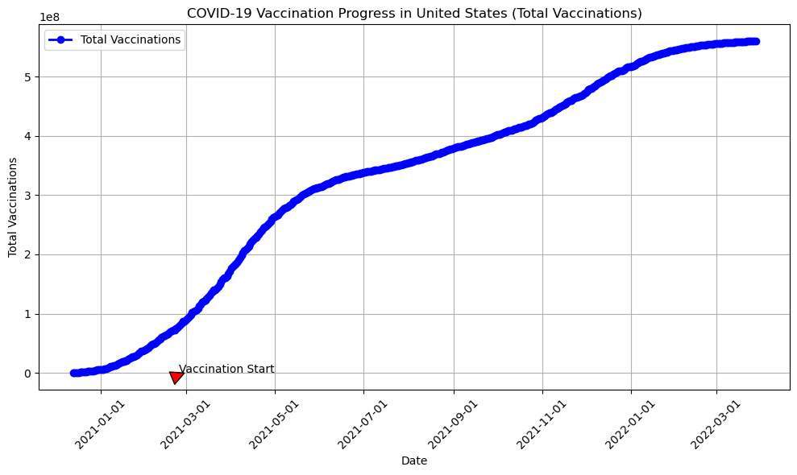The line plot above shows the United States COVID-19 vaccination journey. The horizontal axis displays time, spanning from the initial roll out of vaccines in early 2021 to the present and the vertical axis represent the total vaccinations. The line chart showcases the aspect of the cumulative number of vaccines administered, reflecting the scale of vaccination campaigns.

*Figure 2 COVID-19 Vaccination Progress in United States (daily Vaccinations)*

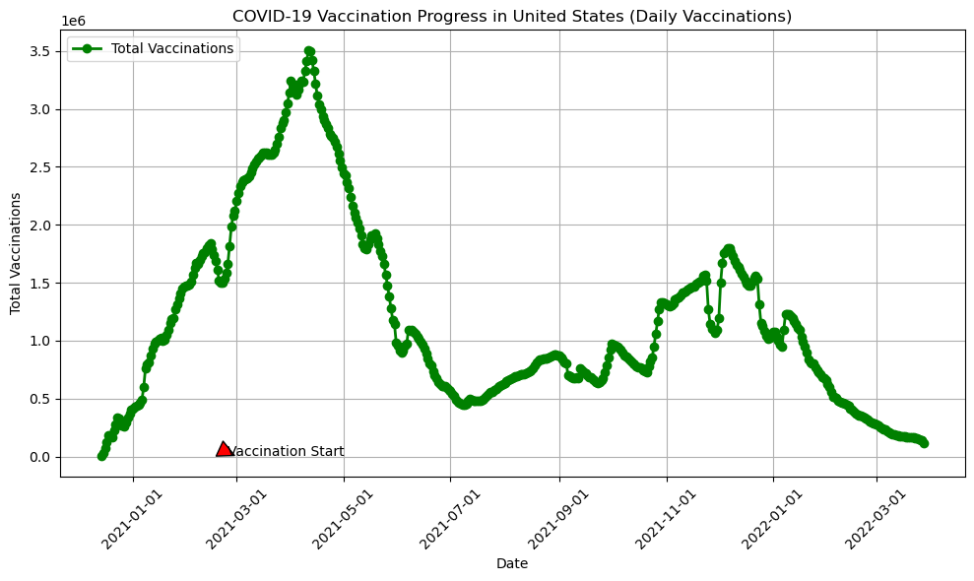

The line chart above provides an in-depth analysis of the united states COVID-19 vaccination progress, specifically focusing on the daily number of vaccine doses administered.

The horizontal axis represents time, extending from the commencement of vaccination early 2021 to the present and the vertical axis shows the number of COVID-19 vaccine doses administered daily in the United States.

From the data visualizations above, the following insights can be drawn;

* **Rapid Growth**: By observing the line charts, we can see instances of accelerated vaccination, which represent the nation's dedication to reaching its population.
* **Milestones Achieved:** Significant milestones, such as achieving millions of doses administered, are visible on the chart.
* **Fluctuations and Peaks:** The chart's daily fluctuations and peaks provide insight into periods of high vaccination activity or potential issues in vaccine distribution.
* **Achieving Milestones:** Milestones and major successes, such as the daily administration of a substantial number of doses, are readily evident.
* **Policy Influence:** Annotations and highlights may give light on the impact of policy changes, government initiatives, and public health measures on daily vaccination trends.

Interactive Elements

In this visualization, the following interactive elements are used:

* **Select Specific Countries**: Selecting a country within the chart legend, the user is able to isolate data for that specific location. This enables the comparation of how different United State has experienced the pandemic and how she approached vaccination.
* **Interactive Annotations:** The chart’s interactive annotations provide context and insights about key events, policy changes, and vaccination campaigns. These annotations reveals additional information and context.

Impact

The elements in this visualization engages and educate the audience on the progression of the COVID-19 pandemic and the role of vaccinations.

1. **Understanding:** The audience gains a clear understanding of how COVID-19 vaccines progressed over time in United States. They can also see the impact of vaccination campaigns on increasing the number of vaccinations.
2. **Engagement:** The narrative-driven approach keeps the audience engaged and informed throughout the visualization. By highlighting milestones and providing context, users are more likely to appreciate the complexity of the pandemic and the importance of vaccination efforts.

Conclusion

We discovered a wonderful story of perseverance and determination of COVID-19 vaccination efforts in the United States. From the initial vaccine rollout to the administration of millions of doses, the country has reached significant milestones. This dedication has resulted in actual success, as indicated by the number of people who have received at least one vaccine dosage and the procedures taken to achieve herd immunity. While there have been setbacks along the road, the influence of legislation, political initiatives, and scientific innovation has led the vaccination trajectory. The plot continues, with the infection still being combated. Data has been a vital tool throughout the journey, affecting policy decisions and providing insights into the collective response. The United States, like the rest of the world, is navigating an ever-changing landscape.

**References**

Sharma, A., Farouk, I. A., & Lal, S. K. (2021). COVID-19: A Review on the Novel Coronavirus Disease Evolution, Transmission, Detection, Control and Prevention. Viruses, 13(2). https://doi.org/10.3390/v13020202